**E-ATTENDANCE SYSTEM**

**A Project Work Synopsis**

**Submitted in the partial fulfilment for the award of the degree of**

**BACHELOR OF ENGINEERING**

**IN**

**COMPUTER SCIENCE ENGINEERING(AIML)**

**Submitted by:**

**ADHIKARI.SAIKIRAN – 20BCS6088**

**KAVURI.VANDHAN MURALI – 20BCS6001**

**RUNJHUN MATHUR – 20BCS6071**

**DWAIPAYAN ROY – 20BCS6043**

**Under the Supervision of:**

### SUPERVISORS NAME

**ARUN MITTAL**



**CHANDIGARH UNIVERSITY, GHARUAN, MOHALI - 140413,**

**PUNJAB**

**MARCH,2022**

#### **INTRODUCTION**

Attendance Management System is software that is used in schools, universities, and institutes to track daily student attendance. It makes it easier to find out about a certain student's attendance in a specific class. The data is sorted by the operators, who are provided by the teacher for a specific class. This approach will also assist in determining a student's attendance eligibility criteria.

**Purpose: -** The purpose of creating an attendance management system is to automate the traditional method of taking attendance. Another reason for designing this programme is to automatically generate the report at the end of the session or in the middle of it.

#### **LITERATURE REVIEW**

Shirodkar M, et al. (2015) [41] proposed attendance administration device the use of the face focus method in which captured faces are matched with the face database of the students and mark attendance Sakshi, et al. Edelweiss Applied Science and Technology, 2021 Citation: Sakshi, Sharma C, Sharma S, Singh P and Khan AI. Advanced attendance management systems: applied sciences and applications (2021) Edelweiss Appli Sci Tech accordingly. Student photographs are captured in one-of-a-kind poses for the duration of the admission method and stored in the college database. Cameras are already established in the gadget which captures the solely frontal photograph of the pupil and matches captured image with the database if the image matches then the device automatically mark the current for that precise student. Reports can be downloaded by means of the authorities at any time from the front end. The creator finished an accuracy of 83.2% from the proposed system. Jayant KN, et al. (2016) proposed attendance management system using hybrid face focus techniques. In this find out about writer set up excessive definition digital camera above the whiteboard of the type which capture all students three times in the total period of the class due to the fact of editions in the pose of the students. Viola-Jones algorithm is viewed via the writer for face detection in their learn about due to the quick feature resolution procedure. The machine will seize and manner statistics in three frames and the frame offers the very best detection charge that body will be considered through the gadget to mark the attendance in excel format.

#### **PROBLEM FORMULATION**

Attendance Management System is software developed for daily student attendance in schools, colleges and institutes. It facilitates to access the attendance information of a particular student in a particular class. This system will also help in evaluating attendance eligibility criteria of a student. By just a click on the mouse, the system will be able to produce the students' attendance report thus reducing the need for manual labour which is prone to human errors and time consuming.

This application is built for automating the processing of attendance. It also enhances the speed of performing attendance task easily.

#### **OBJECTIVES**

The "Attendance Management System" is a piece of software designed to track a student's attendance in college on a daily basis. The staff members in charge of the topics will be responsible for keeping track of the students' attendance. Each member of staff will be given a unique username and password based on the subject they are responsible for. This is where the accurate report based on student attendance is prepared. This approach will also assist in determining a student's attendance eligibility criteria. On a weekly and monthly basis, a report on the student's attendance is generated.

**User Friendly**: User interface is very easy. Data storing and recovery is fast and secured. In addition, application is provided with graphical representation for easier interpretation and analysis.

**Reports are Easily Generated**: Various reports, such as student-by-student attendance, day-by-day attendance, class-by-class attendance, month-by-month-by-month-by-month-by-month-by-month-by-month-by-month-by-month-by-month-by-month-by Instant access to current and historical reports is possible.

**Zero Risks**: There is no paperwork involved, and there is no possibility of human error when manually recording attendance.

#### **METHODOLOGY**

**ANACONDA**

Anaconda is a distribution of the Python and R programming languages for scientific computing (data science, computing device studying applications, large-scale facts processing, predictive analytics, etc.), that targets to simplify package administration and deployment. The distribution consists of data-science packages suitable for Windows, Linux, and macOS. It is developed and maintained via Anaconda, Inc.,

**Visual Studio Code**

Visual Studio Code is a lightweight but powerful supply code editor which runs on your desktop and is on hand for Windows, macOS and Linux. It comes with built-in aid for JavaScript, TypeScript and Node.

**Python**  
Python is often used as a support language for software program developers, for build manage and management, testing, and in many other ways. SCons for build control. Build Bot and Apache Gump for automated continuous compilation and testing. Roundup or Trac for bug monitoring and assignment management.

## **OpenCV**

OpenCV is the most popular library for computer vision. Originally written in C/C++, it now provides bindings for Python.

OpenCV uses machine mastering algorithms to search for faces inside a picture. Because faces are so complicated, there isn’t one easy take a look at that will tell you if it observed a face or not. Instead, there are thousands of small patterns and aspects that ought to be matched. The algorithms smash the task of figuring out the face into heaps of smaller, bite-sized tasks, each of which is effortless to solve. These tasks are additionally called classifiers.

**dlib**

The dlib library, maintained by Davis King, contains our implementation of “deep metric learning” which is used to construct our face embeddings used for the actual recognition process.

**Face recognition**

The face recognition library, created by Adam Geitgey, wraps around dlib’s facial recognition functionality, and this library is super easy to work with and we will be using this in our code. Remember to install dlib library first before you install face recognition.

**JAVA**

Java is used to write purposes for distinct platforms that run JRE and helps functions that run on a single machine like a desktop or cellular phone. Java can also be used to boost purposes that work in a disbursed manner.

pip install click

pip install cmake

pip install Pillow

pip install dlib

pip install face_recognition

pip install flask

pip install gunicorn

pip install Flask-Cors

(NOTE: The use of these methods may change according to the development of application.)

#### **RESULTS AND DISCUSSION**

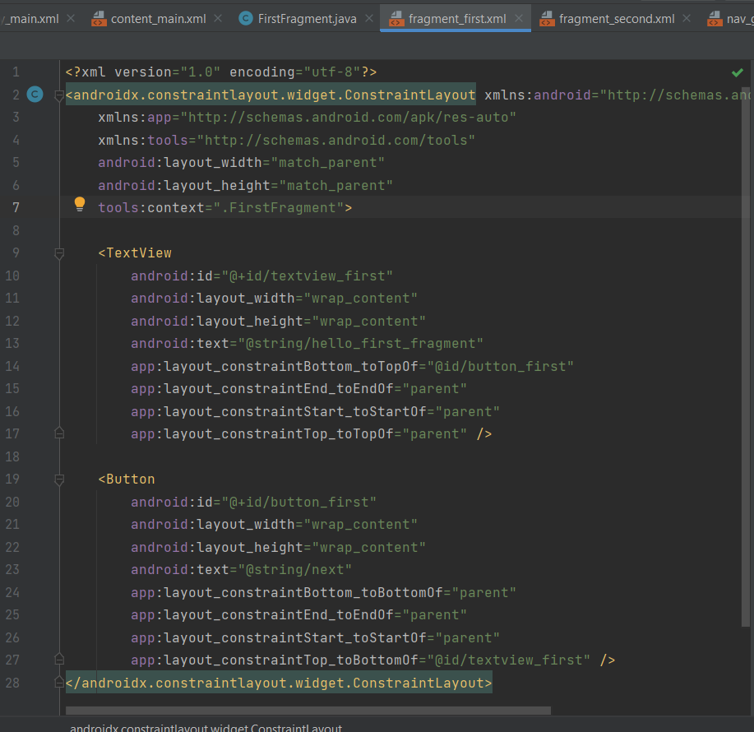

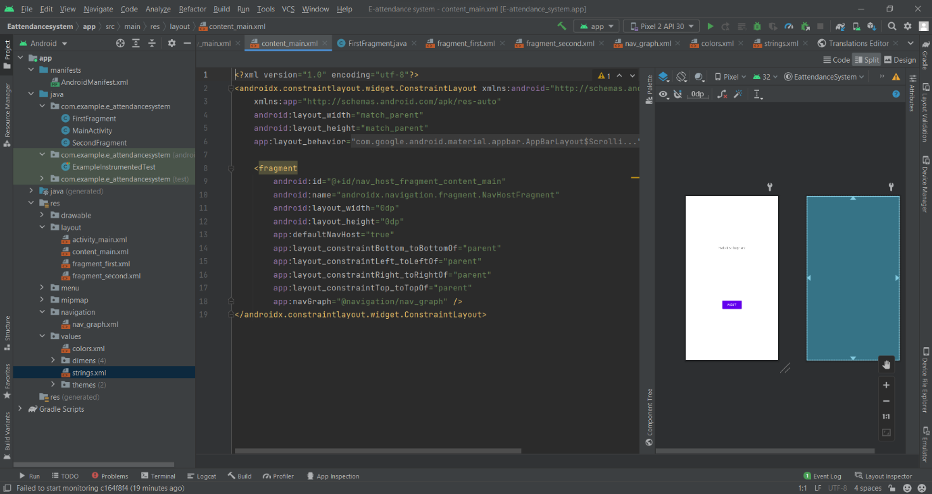



(NOTE: These results are temporary. They may vary after the final product is finished)

#### **CONCLUSION AND FUTURE SCOPE**

The undertaking has a very widespread scope in future. The assignment can be implemented on intranet in future. Project can be updated in near future as and when requirement for the identical arises, as it is very flexible in terms of expansion. With the proposed software of database Space Manager ready and absolutely practical the purchaser is now able to control and therefore run the whole work in a whole lot better, accurate and error free manner. The following are the future scope for the project.

1. Discontinue of particular student eliminate potential attendance.
2. Bar code Reader based attendance system

Attendance administration system maintains music of every day attendance, working hours, breaks, login, and logout time. It prevents staff's time theft. An attendance management device integrates all attendance gadgets such as clever cards, biometric, and facial recognition devices in real-time

#### **REFERENCES**

<https://www.mygreatlearning.com/blog/face-recognition/>

<https://python.plainenglish.io/how-to-deploy-a-face-recognition-web-app-with-flask-react-from-zero-c4c624654646>

<https://realpython.com/face-recognition-with-python/>

<https://youtu.be/uwJltCOrpEI>

[www.google.com](http://www.google.com)